|  |  |
| --- | --- |
| **DOKUMENTASI EKSTERNAL**  External Documentation |  |
| **PROYEK**  ***Project*** |
| **MATAKULIAH <ISYS6211> –**  **WEB-BASED APPLICATION DEVELOPMENT**  ***Subject*** |
| SEMESTER GENAP 2017/2018 ***Even Semester Year 2017/2018*** |

**Sakura Cake Shop**

**Class : BB11**

**Made By :**

**Vincent**

**Abstract**

This documentation is made to show everything about our lab project on Web-based Application Development about Sakura Cake Shop. We want to complete this project because we want to try to learn how to use HTML, CSS, and JavaScript. With the completion of this project means that we have already mastered the basic on how to make a simple website.

**Introduction**

Sakura Cake Shop is the most famous cake shop in Indonesia that sold various type of cake, such as Apple Cake, Baumkuchen, and Lemon Cake. Sakura Cake Shopowner wants to make a new website to celebrates their 20th Anniversary.

This website can help customers to find any information about the Sakura Cake Shop. Customer can also register to become a member and login from this website.

**Documentation**

1. Home Page

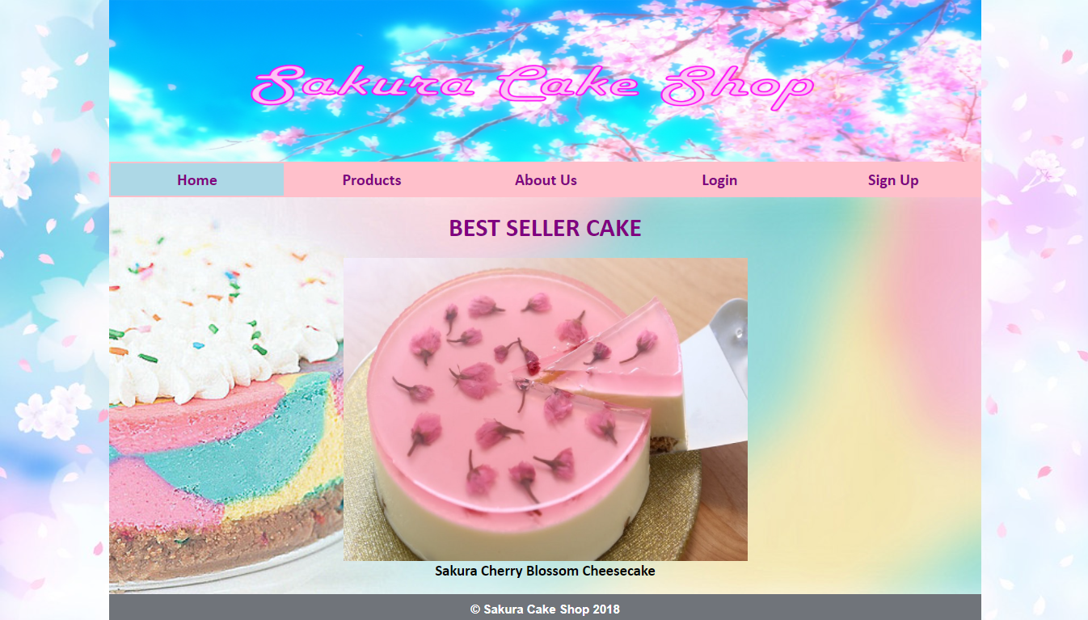

Clicking on this Home page, customer can see the shop’s best seller cake right now which is Sakura Cherry Blossom Cheesecake.

1. Products Page

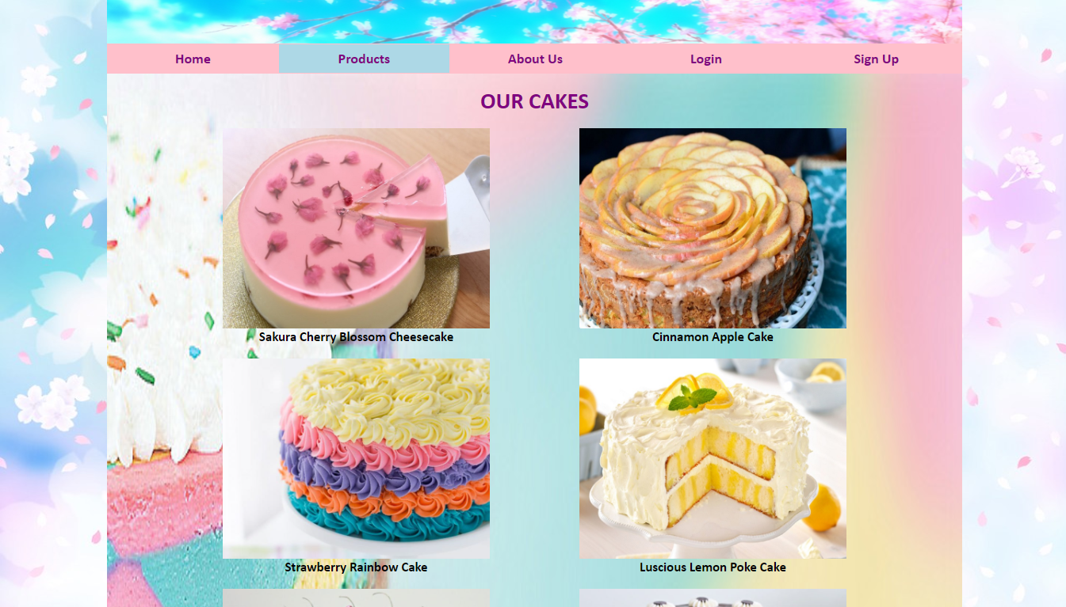

Clicking on this Cake page, customer can see all of the cakes that are available in the shop with the cake’s name and the picture.

1. About Us Page

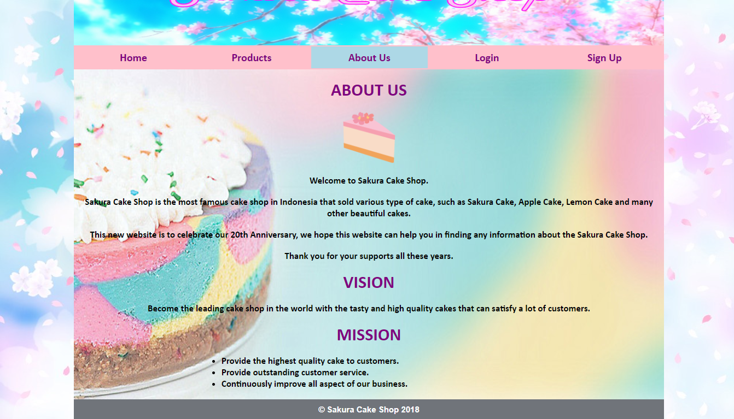

Clicking on this About Us page, customer can see Sakura Cake Shop information such as vision and mission.

1. Login Page

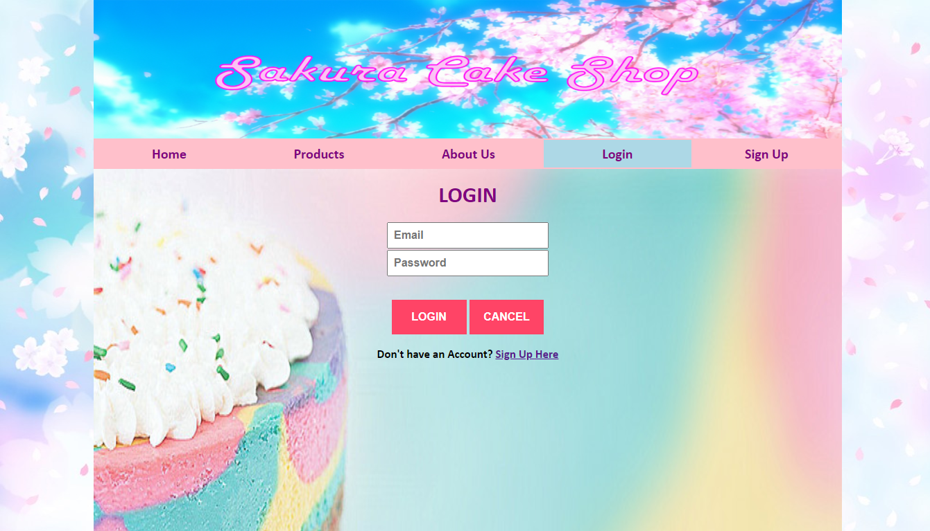

Clicking on this Login page, customer can login to the website by entering the email and password into the website and then click the Login button, or customer can cancel the login by clicking the Cancel button and it will redirect to the Home page. If customer doesn’t have an account, customer can click the “Sign Up Here” link to redirect customer to Sign Up Page.

1. Sign Up Page

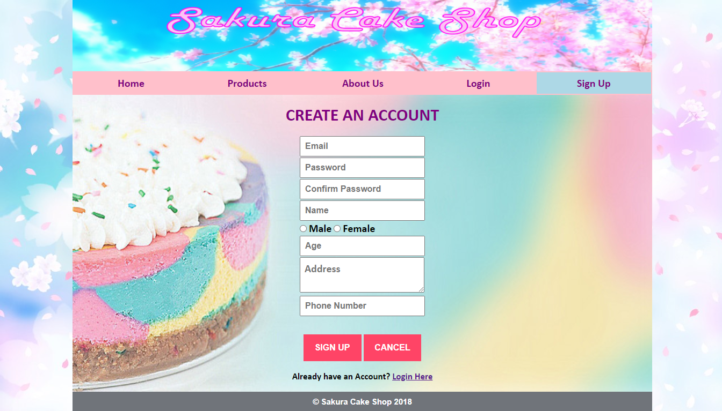

Clicking on this Sign Up Page, customer can register as a member of Sakura Cake Shop by entering the appropriate email, password, name, gender, age, address, and phone number into the website and then click the Sign Up button, or customer can cancel the register by clicking the Cancel button and it will redirect to the Home page. If customer already have an account, customer can click “Login Here” link to redirect to Login Page.